Virtual Science Museums

Let the museum come to you!
These museums have virtual tours and/or special events to enrich science learning at home.
  National Museum of Natural History - Virtual Tours  The Smithsonian, National Museum of Natural History virtual tours allow visitors to take self-guided, room-by-room tours of select exhibits and areas within the museum from their desktop or mobile device. | AMNH Museum Virtual Tour  See "inside the Museum" in this virtual tour from Google Arts and Culture. |   Oxford University’s  History of Science Museum Virtual Tour  Explore the history of science through objects, their inventors and how they changed the world.
Natural History Museum (London)  Virtual Tour of the Natural History Museum- London  For all things natural history! | 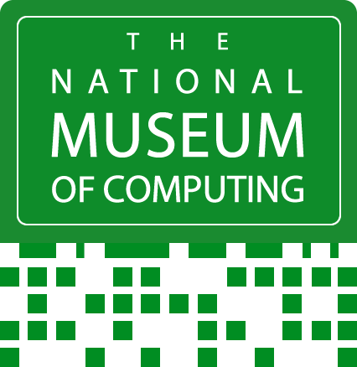  The National Museum of Computing (TNMOC) Virtual Tour-England  Home to the world's largest collection of working historic computers. |   Boston Children’s Museum Virtual Tour  A museum tour of the renowned children’s museum; get inspired!

